Implementing Omni-Channel Support in Salesforce Service Cloud



Introduction of Omni-channel support

A huge step forward in the evolution of customer service is omnichannel assistance, which allows companies to interact with customers through any number of channels.

In the past, companies would handle customer inquiries through several channels like phone, email, and chat, which frequently led to disjointed and inconsistent customer experiences.


Nevertheless, with the advent of Omni-channel support, companies can now effortlessly integrate and manage client interactions across many channels in a joined and consistent manner.

Omnichannel strategies help companies create integrated and user-friendly tools for their customers, allowing them to effortlessly transition between different channels of communication without losing track of their progress or interactions.

All of a customer's data and conversations are synced across all channels, so agents can see the big picture no matter how the consumer contacts them—by phone, email, chat, or social media. Maintaining this level of consistency fosters consumer happiness and loyalty.

Not only that, but Omni-channel encourages and helps companies provide clients with focused and personalised service.

By collecting data from different channels and touchpoints, businesses may learn more about customers' priorities, activities, and requirements. In the end, this helps them tailor their interactions and products to each customer's unique demands, which increases engagement and loyalty.

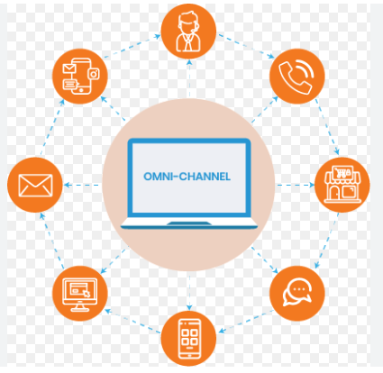

Businesses can reap significant benefits from Omni-channel assistance, which goes beyond just enhancing the client experience. Standardising processes allows businesses to enhance operational effectiveness, minimise reaction times, and optimise resource distribution, leading to higher service quality and consistency.

In addition, organisations can gain valuable data and raw information that can aid in strategic decision-making and ultimately lead to corporate success by analysing and monitoring client contact history and demographics across channels.
In general, implementing Omni-channel support is a game-changer for customer service. It allows companies to provide customers with more personalized, efficient, and effective interactions while improving operational efficiency and building lasting relationships with customers.

Implementing Omni-Channel Support

With Salesforce Service Cloud's omni-channel support, businesses can easily communicate with customers through several channels, such as chat, email, phone, and social media.

Implementing and advancing Omni-channel assistance leads to customer pleasure which in turn provides customer care. It intelligently routes incoming requests to the maximum appropriate available agent based totally on skill set, workload, or priority, ensuring brief and customized responses. This enhances agent productivity, reduces response times, and improves normal customer satisfaction. Through adopting Omni-Channel support, organizations can supply a constant and extraordinary customer experience throughout all communication channels.

Furthermore, omni-channel help integrates multiple communication channels into a unified platform, improving client experience and engagement. It centralizes client data for customized interactions throughout channels, improving operational efficiency. by leveraging AI-powered equipment and analytics, businesses can optimize client interactions and drive loyalty. This method presents an competitive gain by adapting to evolving client alternatives and marketplace dynamics.

To set up Omni-channel support in Salesforce Sales Cloud, you need to do the following:

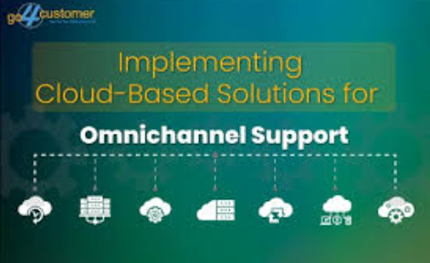

Communication Medium Setup

One of the first steps in providing excellent customer service is establishing multiple channels of contact for clients to use when contacting the company. Businesses can cater to their consumers' preferred methods of communication by providing options such as chat, phone, email, and social media.

It is crucial that the channels utilised are acceptable to the stakeholders and that they avoid any problems related to technical issues when using these channels. As a result, customers will have no trouble getting in touch with support services whenever they need them, which should lead to faster problem resolution and overall happiness. By pursuing a multi-channel strategy, firms demonstrate their dedication to meeting diverse client demands and providing exceptional service.

Routing

Timely resolution of client concerns is ensured via effective routing. Businesses can learn which agent gets each customer's message by looking at their qualifications and availability.

This guarantees that a query is sent to the best agent for the job, the one who can handle the issue effectively and efficiently. Also, it helps to distribute the agents' tasks evenly, which keeps them from getting overwhelmed with queries and ensures that everything runs well.

As a result, when consumers receive high-quality service, they are more likely to contact resources when they need them, which boosts the efficiency of customer support operations and leads to a loyal customer base.

Agent Limits

Setting maximum restrictions on the number of clients one agent can manage under one cover helps keep service quality high and prevents agents from being overworked. Agents will be able to attend to each client in a timely manner because they are working within predetermined boundaries.

This way, we can be sure that our customers' assistance needs will be met quickly and with adequate quality. Another benefit of a well-managed agency workload is that agents can take brief breaks without sacrificing productivity, which in turn lowers stress levels and improves morale.

To ensure maximum efficiency and effectiveness, it is recommended to routinely analyse workload and performance data and implement a sufficient number of agent restrictions.

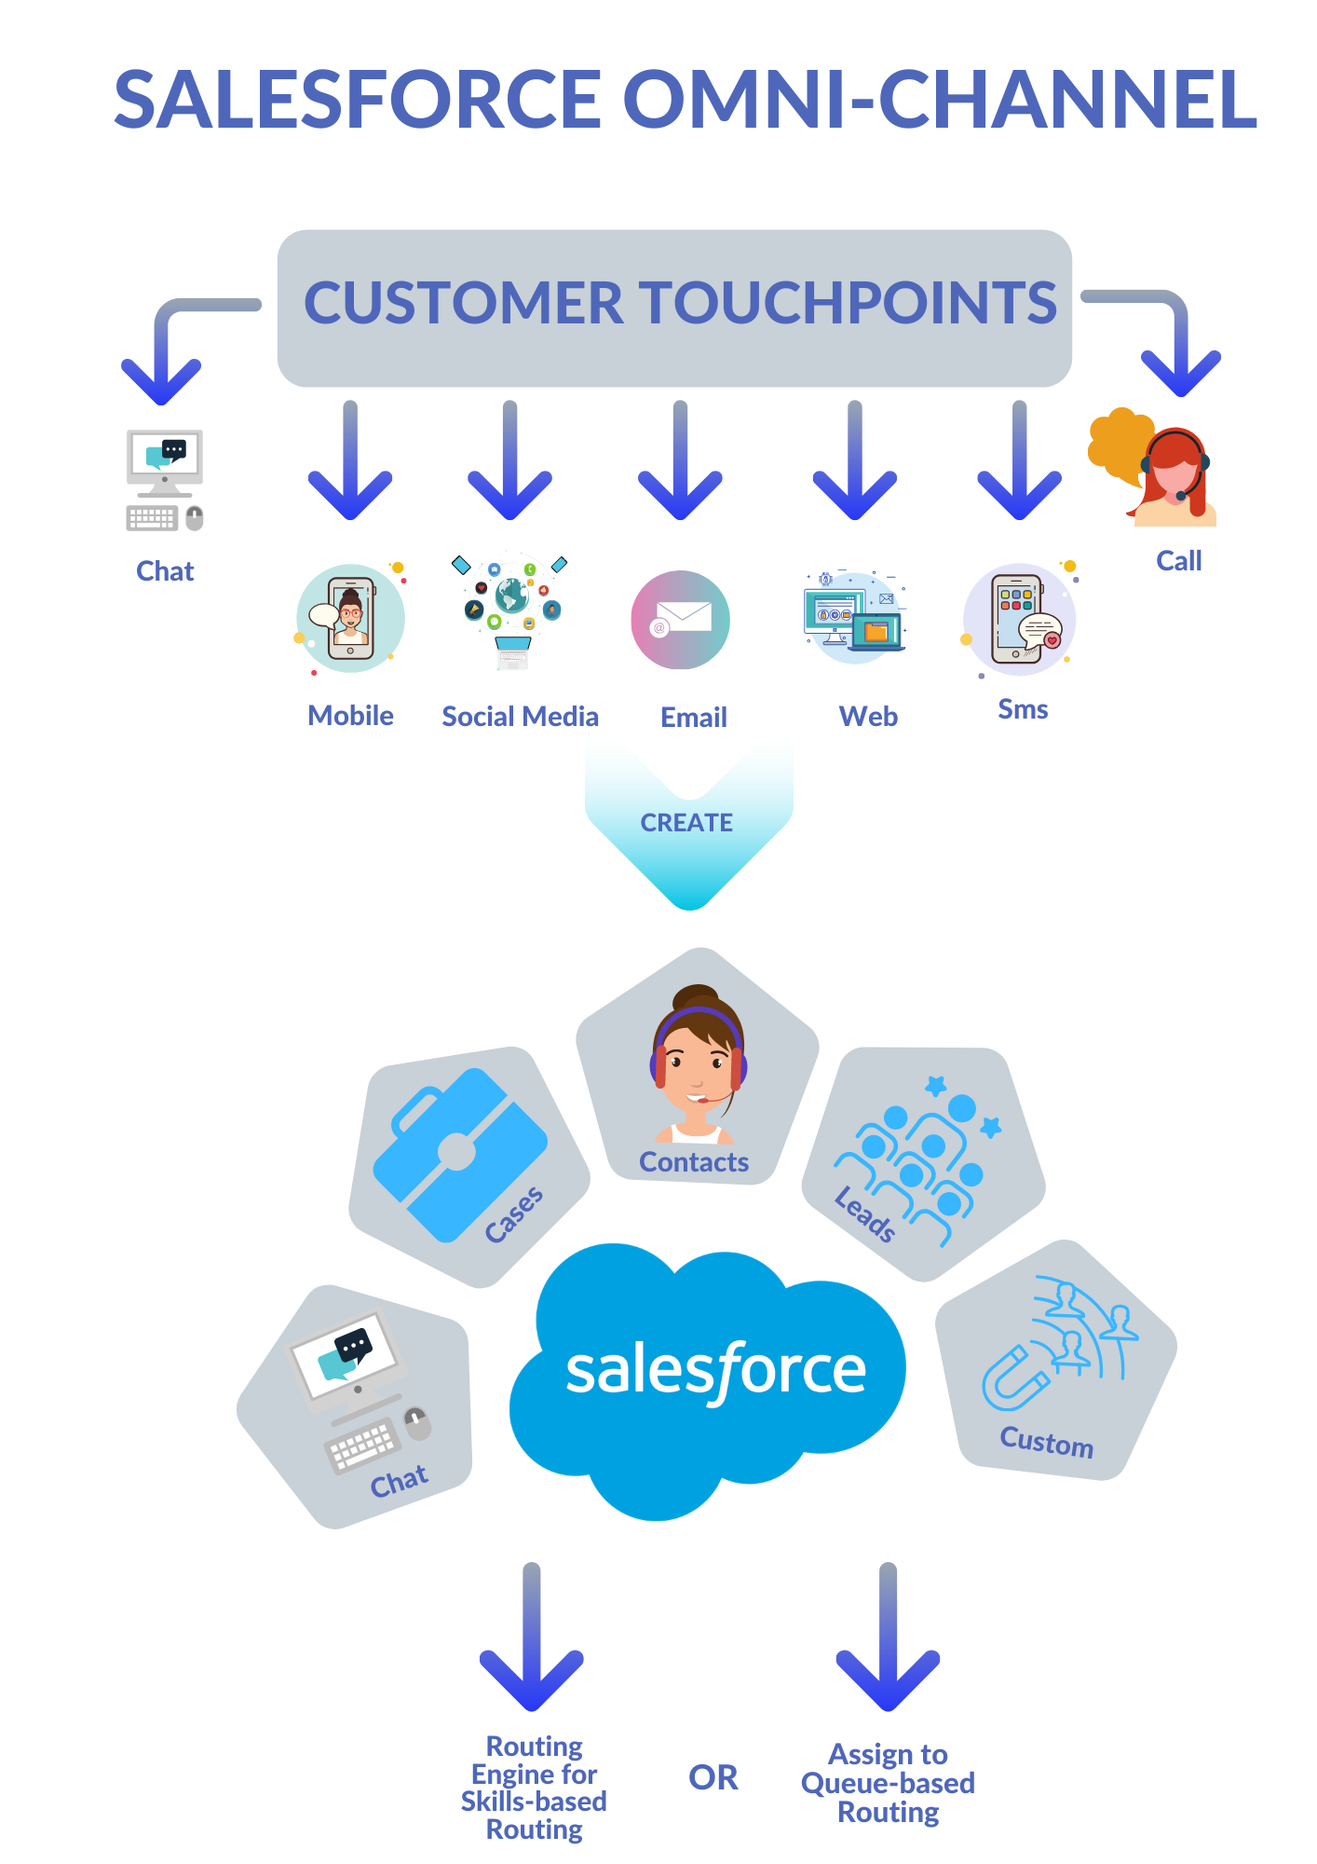

Priority Lists

Improved customer satisfaction is the result of promptly addressing critical concerns, which can be achieved by creating priority lists. Problems are resolved more rapidly and readily when they are ranked according to their importance and urgency.

This shows that we are responsive to our client's needs and that we handle key issues swiftly to prevent them from escalating.

Task Prioritization:
Utilize priority ranges (e.g., high, Medium, Low) to categorize incoming client interactions based totally on their urgency and importance.

Channel-Specific Priorities:
Assign distinctive priorities to interactions from numerous channels (e.g., Chat, email, phone) to make sure well timed and appropriate responses.

Skill-Based Routing:
Implement priority-based routing rules to direct high-priority interactions to specialized agents with the required skills to handle specific issues effectively.

In addition, they have an easier time determining which large-scale workload allocation concerns to prioritise when they've determined where their team can be most effective in resolving these difficulties and managing service delivery as a whole.

Optimizing Omni-Channel Support in Salesforce Service Cloud

Stakeholders must adopt a strategy that consistently enhances and refines the platform if they want to utilise the Omni-channel support within Salesforce Service Cloud fully.

Optimizing Omni-Channel assist in Salesforce service Cloud includes customizing routing guidelines, monitoring agent overall performance, providing continuous training, and gathering customer feedback. This approach enhances performance, improves agent productiveness, and elevates the overall customer experience across multiple communication channels.

So performance monitoring, agent education, consumer input, and ongoing improvement should be prioritised. This means companies will have the tools they need to keep their Omni-channel support system running smoothly and providing first-rate service to customers.

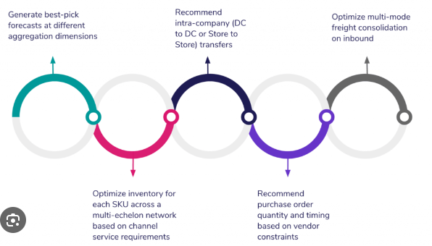

Track Performance

It's essential to closely monitor the performance of the Omni-channel support system to uncover areas that could use some improvement. Then, make the required adjustments.

Respondence time, error handling time, and customer satisfaction ratings are some of the performance measures that stakeholders are expected to take into account using the reporting and analytics capabilities in Salesforce Service Cloud. This data-driven technique allows organizations to identify trends, pinpoint regions for development, and optimize guide operations for improved performance and client satisfaction.

They can learn the effect their support methods have on the company and where to make adjustments to boost performance with these metrics.

Agents' Training Sessions

To put this effective performance into action, the cost of efficient agents is still a tool. In order for support personnel to deliver first-rate customer service through Omni-channel communication, it is necessary to train them in the right areas.

Agents should be trained on the features and functionalities of Salesforce Service Cloud's Omni-channel support platform as part of this. Included in agent training sessions should be instructions on how to communicate effectively, best practices for responding to client inquiries, and the utilisation of the Omni-channel support tools at their disposal.

In order for a company to be well-prepared, all agents must receive training and have access to the resources they need to meet and exceed customer expectations consistently.

Customer Feedback

Accurate input on customers' requirements, preferences, and pain areas can help understand their experience using Omni-channel assistance. Organisations should implement systems to gather feedback at each customer touchpoint to gather customer input on support system engagement. Through gathering and analysing comments through surveys and direct inquiries, businesses can identify trends and implement actionable improvements to enhance customer satisfaction and loyalty.

The information collected from this feedback can shed light on the strengths and opportunities for improvement of the Omni-channel support system.

Distinguished Features of business with and without Omni-Channel Support

Omni-channel support revolutionizes client engagement by using seamlessly integrating multiple communication channels right into a unified platform. This approach centralizes client information, enabling personalized interactions and real-time engagement via AI-powered equipment. businesses leveraging omni-channel techniques gain an competitive aspect by using delivering steady, efficient, and adaptive client experiences throughout diverse touchpoints. In comparison, agencies without omni-channel support often face fragmented client interactions, disparate records silos, and operational inefficiencies, limiting their capacity to meet evolving client expectancies and marketplace needs.
Below are few differences of with and without Omni-Channel:

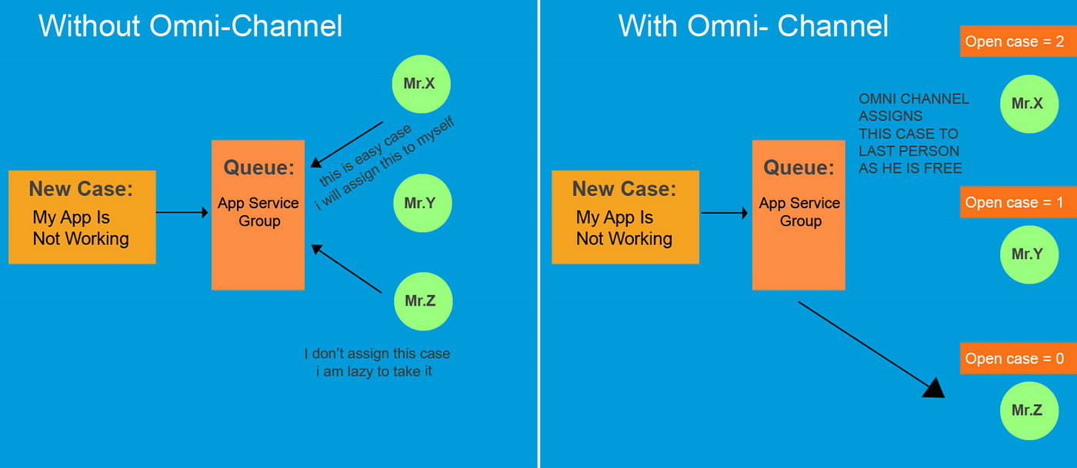

Aspect | Without Omni-channel Support | With Omni-channel Support
Customer Experience | Interactions might be confusing and slow | Interactions are smooth and quick
Team Management | Different teams handle different channels | All teams work together to handle all channels
Service Quality | Quality of service may vary | Service quality is consistent and high
Customer Frustration | Customers may get annoyed and frustrated | Customers are happier and less frustrated
Visibility and Tracking | Businesses can't see all customer interactions | Businesses can track all interactions easily
Personalization and Efficiency | Hard for businesses to give personalized service | Businesses can give personalized service more easily
Impact on Customer Satisfaction | Customers may not be happy and might leave | Customers are happier and more likely to stay

